**What is the difference between synchronous and asynchronous controllers in ASP.NET Core?**

**Synchronous Controllers:** Controllers that handle requests in a blocking manner, waiting for tasks to complete before sending a response, which can lead to thread blocking and reduced scalability. **Asynchronous Controllers:** Controllers that handle requests in a non-blocking manner, allowing background processing of tasks using the `async` and `await` keywords, leading to better performance and scalability for I/O-bound operations.

**What is the difference between “async” and “await” in C#?**

Ans: "async" is a keyword used to define a method that can run asynchronously, allowing it to perform non-blocking operations. "await" is used inside an async method to pause execution until the awaited task is complete, without blocking the calling thread.

**First or default and single or default**

Single

It returns a single specific element from a collection of elements if element match found. An exception is thrown, if none or more than one match found for that element in the collection.

SingleOrDefault

It returns a single specific element from a collection of elements if element match found. An exception is thrown, if more than one match found for that element in the collection. A default value is returned, if no match is found for that element in the collection.

## First

It returns first specific element from a collection of elements if one or more than one match found for that element. An exception is thrown, if no match is found for that element in the collection.

## FirstOrDefault

It returns first specific element from a collection of elements if one or more than one match found for that element. A default value is returned, if no match is found for that element in the collection.

### **When to use Single, SingleOrDefault, First and FirstOrDefault**

You should take care of following points while choosing Single, SingleOrDefault, First and FirstOrDefault:

1. When you want an exception to be thrown if the result set contains many records, use Single or SingleOrDefault.
2. When you want a default value is returned if the result set contains no record, use SingleOrDefault.
3. When you always want one record no matter what the result set contains, use First or FirstOrDefault.
4. When you want a default value if the result set contains no record, use FirstOrDefault.

### **Perfomance of SingleOrDefault and FirstOrDefault**

FirstOrDefault usually perform faster as compared SingleOrDefault, since these iterate the collection until they find the first match. While SingleOrDefault iterate the whole collection to find one single match.

What is the difference between Configuration and Configuration service in program . cs

In [ASP.NET](http://asp.net/) Core, ConfigureServices and Configure are two distinct methods that play different roles in the application's startup process. Here are the key differences between them:  
  
ConfigureServices: This method is responsible for configuring services and setting up dependency injection. Services are components or dependencies that your application will use. This method is called at application startup and is where you register services with the dependency injection container.  
  
  
Configure: This method is responsible for configuring the request processing pipeline. It sets up middleware components that handle HTTP requests and responses. The order in which middleware is added in this method determines the order in which they are executed during request processing.

Activate to view larger image,

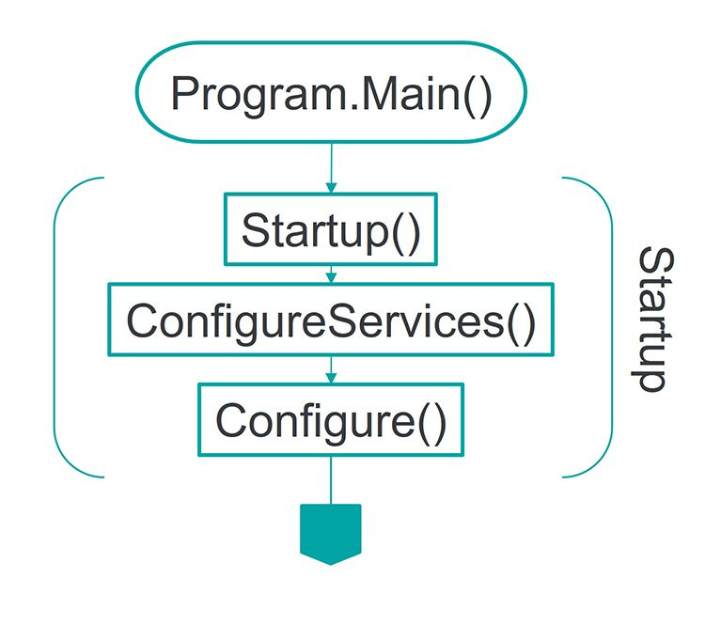

How to connect Application with database

What is Blazor? How is it different from other web frameworks?

Ans: Blazor: A framework for building interactive web applications using C# and .NET instead of JavaScript, allowing developers to create client-side web apps with WebAssembly or server-side apps with SignalR. Difference from Other Web Frameworks: Blazor allows the use of C# for both client-side and server-side development, providing a unified programming model, whereas traditional web frameworks often rely on JavaScript for client-side behavior.